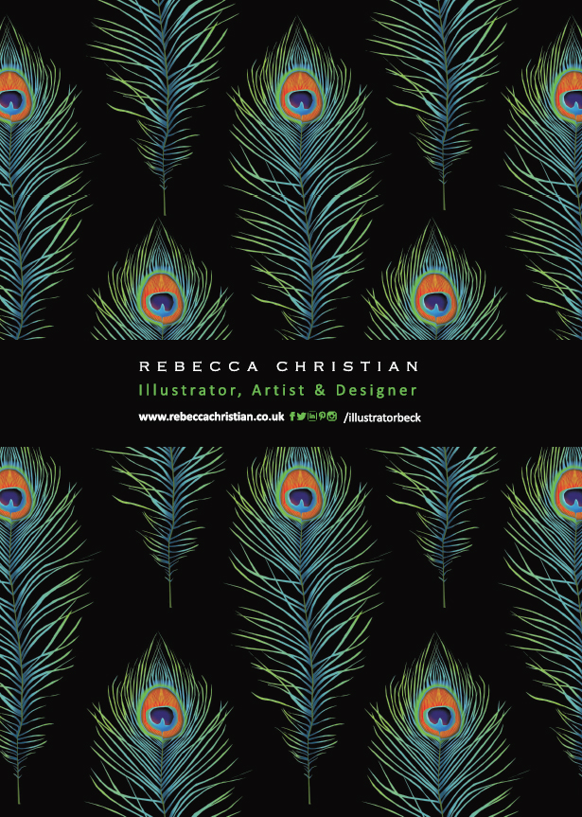
As a British designer Rebecca is passionate about nature, with a degree in scientific illustration and 20 years experience in the design industry,
she has used her skills to create her product range which includes:
ART PRINTS . GREETING CARDS . JEWELLERY . SCARVES . WALLPAPER
Selling in several museums - Liverpool Museum, Atkinson Gallery Southport,
Williamson Wirral, in many independent gift shops and online across the world.

Stock the ‘Rebecca Christian’ brand and tap into the international demand for naturalist,
authentic British design which epitomises the contemporary appreciation for the natural world
and all things ecological.
Enthuse your customers with Rebecca’s passion for the beauty and fragility of nature expressed
in her watercolour artwork....

Best Seller Bundle Page 3
Love & Devotion Page 4&6
Red Squirrel (Gifts) Page 5
Seahorse (Gifts) Page 7
Counting with Ladybirds & Bird on Blossom Page 8
British Coast & Countryside Page 9
Butterfly (Gifts) Page 10
Foxy & Tipsy Toad Page 11
Frisky Feline Page 12
European Eagle Owl Page 13
British Butterflies Page 14
Liverpool Liver Bird Page 15
Liverpool (Gifts) Page 16
Robin & Peacock Feather Page 17

Greeting cards are created from original art ©Rebecca Christian.
Blank inside 150 x 150mm,printed in UK on FSC certified 300gsm card stock,
supplied cello-wrapped with kraft envelope.

SPECIAL OFFER - BEST SELLER BUNDLE

New to Rebecca Christian’s brand? This best seller bundle offers a great starter solution.
A combination of unique best selling designs, created from original watercolour art!
This bundle also offers a fantastic core stock with extra designs available for seasons
throughout the year. ORDER YOUR BUNDLE TODAY!
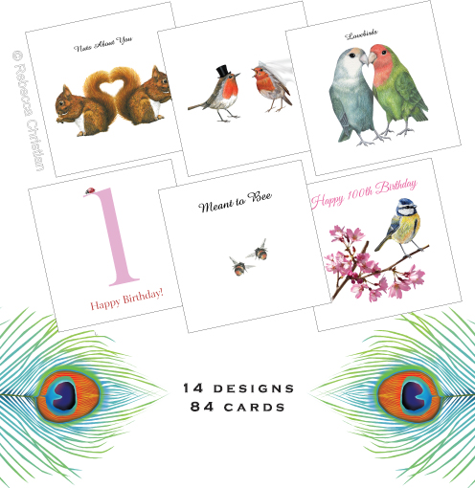
Includes 6 of each* of the following designs: Squirrels - Nuts About You, Lovebirds, Love Bugs,
Meant to Bee, Mr & Mrs Horse, Mr & Mrs Squirrel, Mr & Mrs Owl, Mr & Mrs Robin,
Counting with Ladybirds (1,2,3) *2 of each, Flirty at 30, Foxy at 40, Old Chap, Tipsy Toad,
Bird on Blossom (60-100) *1 of each.
LOVE & DEVOTION GREETING CARDS
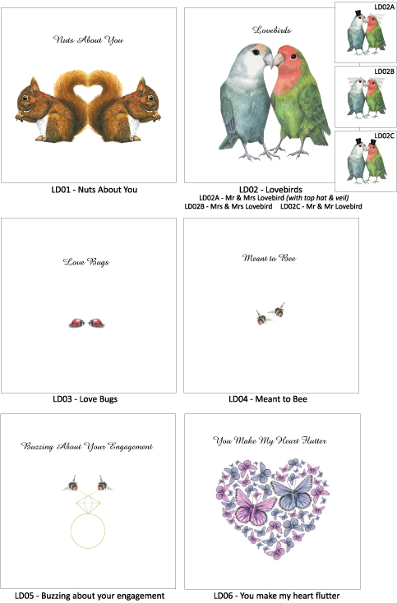
RED SQUIRREL GIFTS

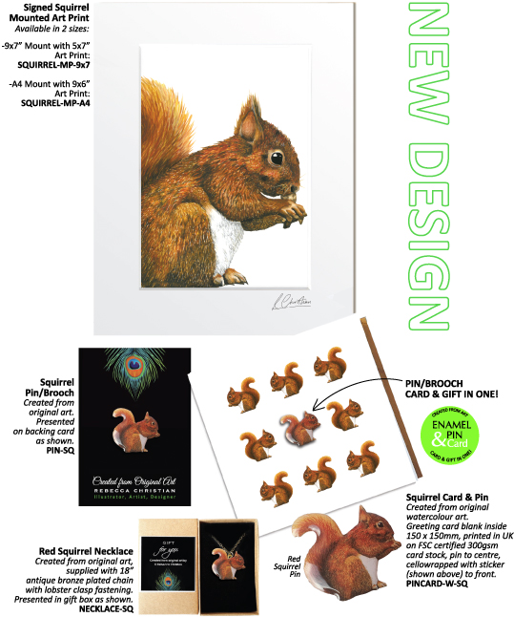

LOVE & DEVOTION GREETING CARDS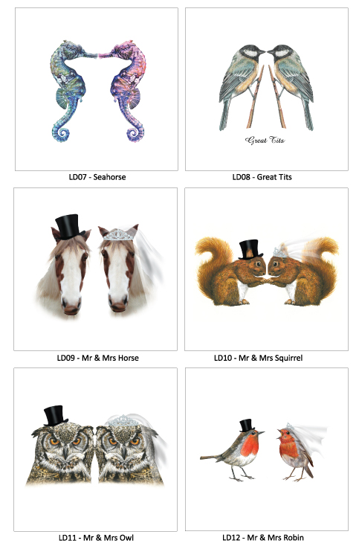
SEAHORSE GIFTS

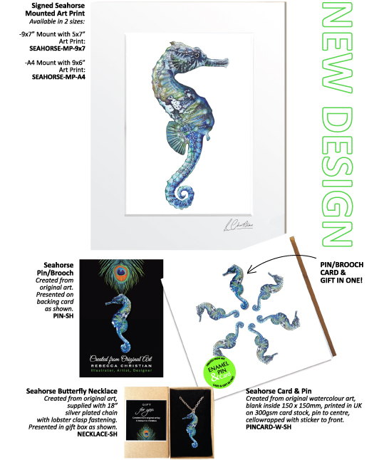

COUNTING WITH LADYBIRDS & BIRD ON BLOSSOM GREETING CARDS

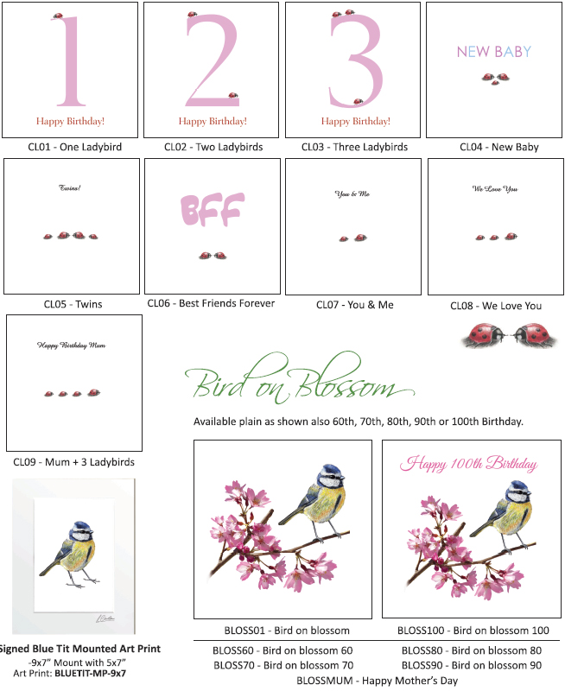

BRITISH COAST & COUNTRYSIDE GREETING CARDS
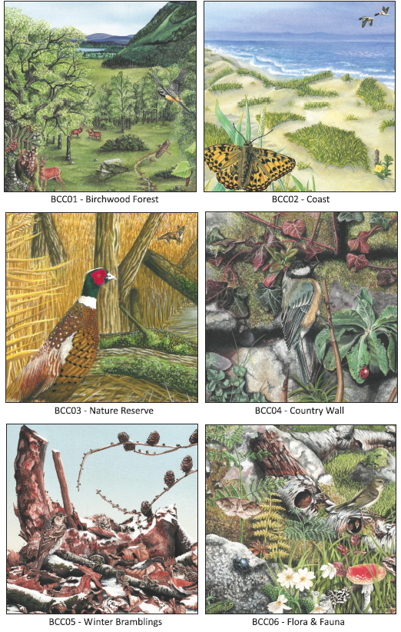
BUTTERFLY GIFTS

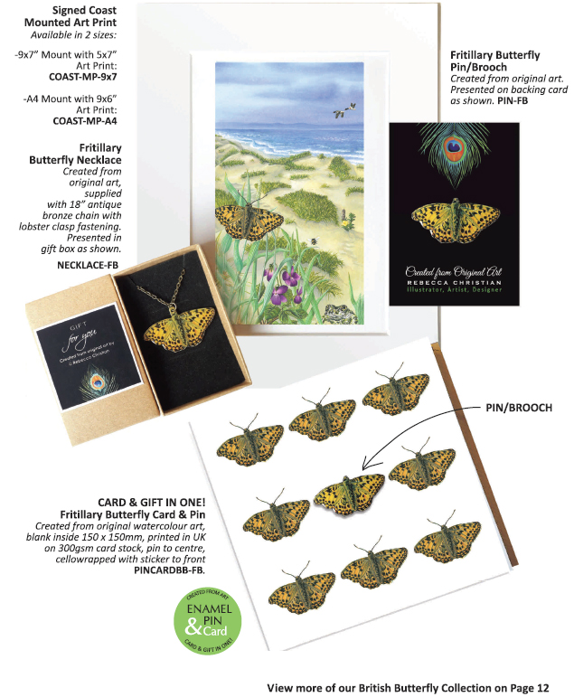

FOXY & TIPSY TOAD GREETING CARDS

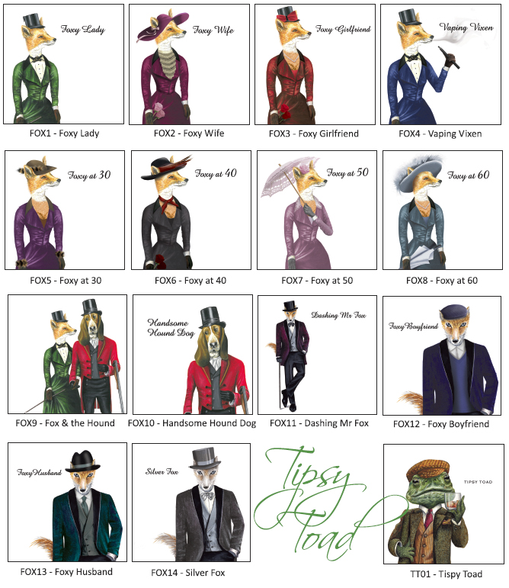

FRISKY FELINE GREETING CARDS
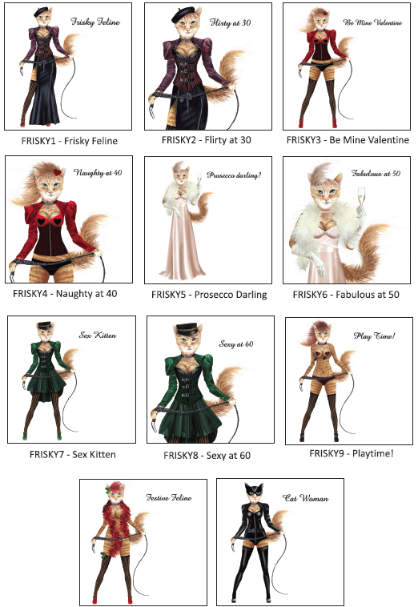
EUROPEAN EAGLE OWL GREETING CARDS

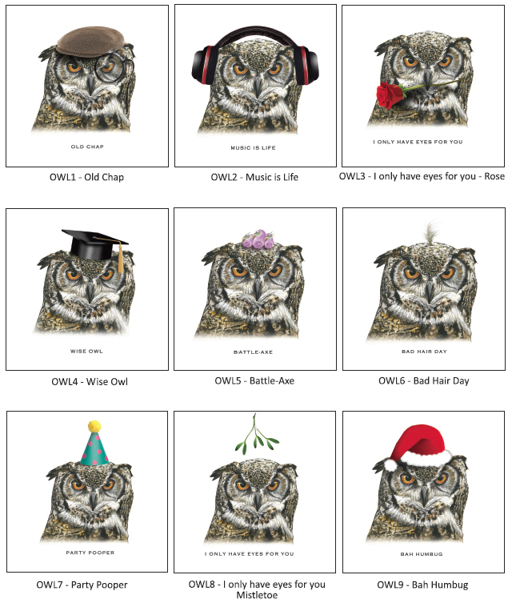

BRITISH BUTTERFLIES GIFTS

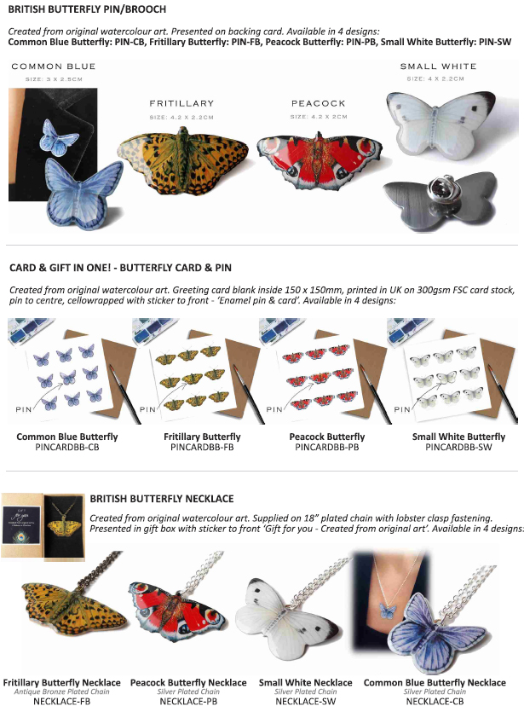

LIVERPOOL LIVER BIRDS GREETING CARDS

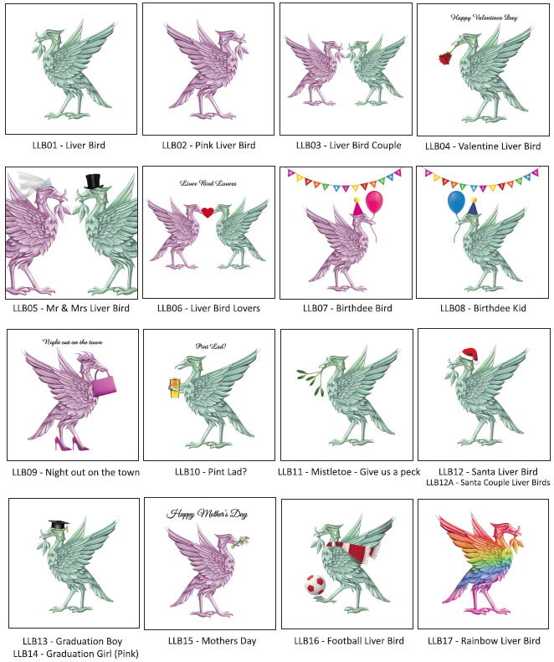

LIVERPOOL GIFTS

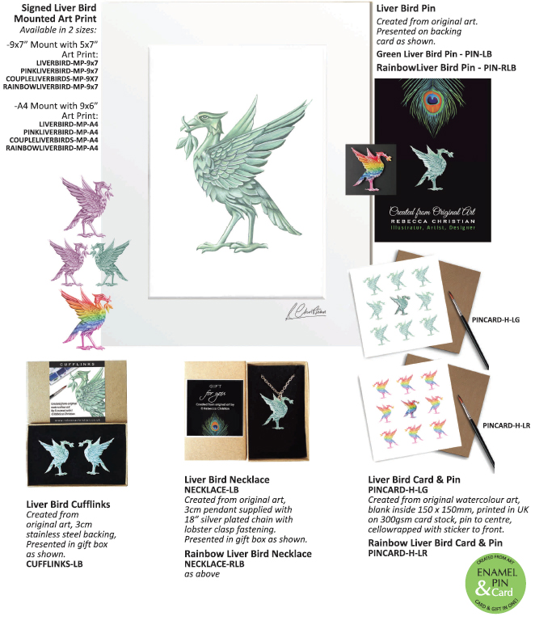

ROBIN & PEACOCK FEATHER GREETING CARDS

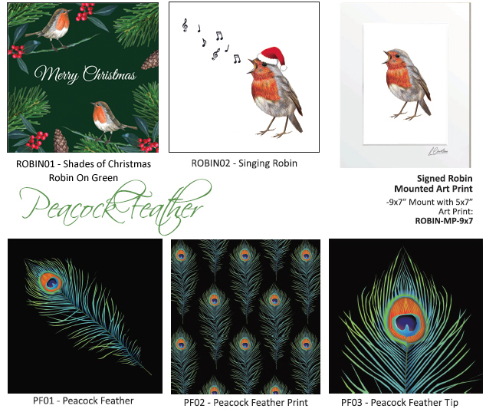

Contact Rebecca Christian to place an order:
sale@rebeccachristian.co.uk
07751983682
